GROUP 23 CHART ANALYSIS WITH NSSF CUSTOMER SUPPORT DEPARTMENT SOFTWARE PROJECT: SOFTWARE DESIGN DOCUMENT

Names: Ssemakula Julius Ociba James Nambafu Isaac Nuwagaba Drake Milton

TABLE OF CONTENTS

1. INTRODUCTION 2

1.1 Purpose 2

1.2 Scope 2

1.3 Overview 3

2. SYSTEM OVERVIEW 3

3. SYSTEM ARCHITECTURE 4

3.1 Architectural Design 4

3.2 Decomposition Description 5

3.3 Design Rationale 9

4. DATA DESIGN 9

4.1 Data Description 9

4.2 Data Dictionary 9

5. COMPONENT DESIGN 11

Module 1: User Verification module 11

6. HUMAN INTERFACE DESIGN 14

6.1 Overview of User Interface 14

Interface Architecture 14

6.2 Screen Images 15

6.3 Screen Objects and Actions 16

7. REQUIREMENTS MATRIX 16

8. APPENDICES 17

8.1 GLOSSARY 17

8.2 References 19

# INTRODUCTION

## Purpose

This document defines the requirements specifications of the chat analysis with NSSF customer support department version1.0 for analyzing and visualizing the chat history with their clients.

This document covers the specifically the analysis of the chat between the client and customer care support at NSSF.

## Scope

The chat analysis with NSSF customer support department system will analyze and visualize the chat history between the clients and the customer care department to determine problems faced by the clients and how the customer care department interacts with the clients towards helping to solve their problems. It will be based a computer that has RStudio, a free and open source integrated development environment for R programming language installed on it together with the Shiny packages and other relevant packages.

The objective of the system is to provide a visual and statistical representation of the Chat history to the NSSF agency which will be assist the agency in making operational plans, strategic planning and decision making to improve communication rate between the customer care department and the client.

The objectives of the system are:

* To analyze the email content and identify the most queried subject or what visitors complained of most.
* To get rid of inapplicable data.
* To also analyze employee efficiency because it is not the same for the different employees.
* To use this data and predict the time periods when visitors use the system most so that NSSF customer care is prepared.
* To visualize this data and based on the feedback of visitors on certain issues, NSSF can know how better to sensitize the services it offers.
* To visualize this data and know which search engines that the visitors use most to access their system.
* To also visualize this data and know where most visitors come from.

This project will aid in the analysis process and also provide a scientific basis for making decisions and taking actions aimed at improving operations of the NSSF Organization.

## Overview

This document has 8 sections that explain its use to the user

The **Introduction** defines the system’s objective and the summary of the system functionality so as to give the reader a good understanding of the system goals.

The **System Overview** explains to the reader the general system functionality and its design.

The **System Architecture** has the detailed view of the different conceptual requirements for setting up the system in terms of hardware and software.

The **Data Design** defines the data storage techniques and the format of the data for each of the stored data files.

The **Component Design** describes how the different components of the system interact to satisfy the user needs.

The **Human machine interface** explains to the reader the needed skills of the system’s interface in order to be able to interact freely with the system.

The **Requirements matrix** shows the system components that satisfy each of the functional requirements from the SRS document.

**Appendices** contains the glossary where all the key terms used in this document are defined

# SYSTEM OVERVIEW

From the chart analysis history between the clients and customer care support department, The NSSF chart Analysis system has been developed with an aim of analyzing and visualizing chat statistics in NSSF organization using the various statistical tools of analysis, visualization and prediction to assist in planning and decision making. The **system context diagram** below shows the system’s functionalities.

**System Context Diagram**

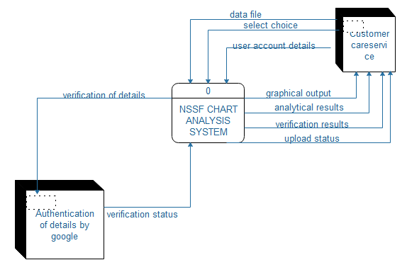

Figure 2.01: System Context Diagram

# SYSTEM ARCHITECTURE

## Architectural Design

The diagram below shows how the system was decomposed giving a general understanding of how the individual sub systems work together.

**Conceptual Diagram**

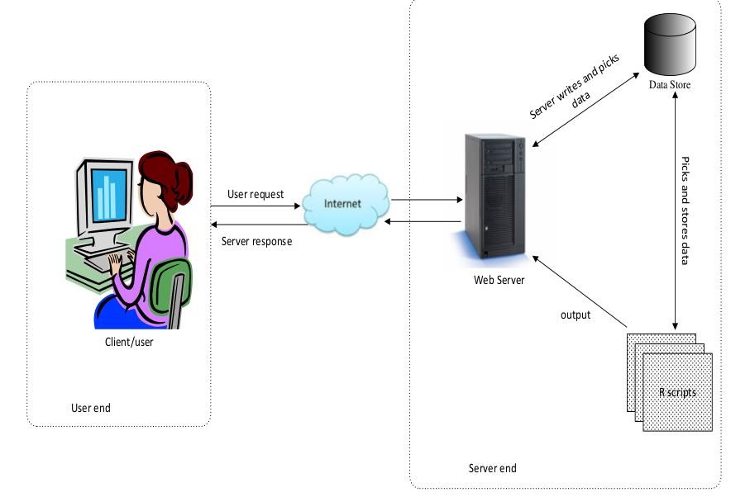

Figure 3.01: Conceptual Diagram

**3.2** **Decomposition Description**

The system functionality has been broken down and is represented as a functional decomposition diagram and data flow diagrams.

##### Functional Decomposition Diagram

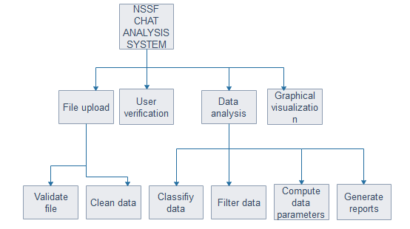

Figure 3.0.2: Functional Decomposition Diagram

##### Level 1 Data Flow Diagram

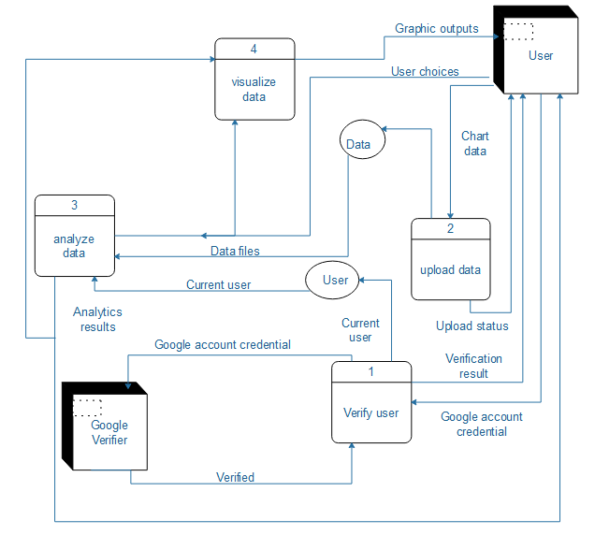

Figure 3.0.3: Level 1 Data Flow Diagram

##### Level 2 Data Flow Diagrams

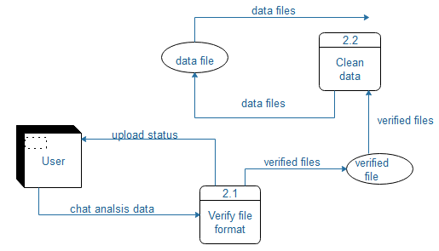

###### Figure 3.0.4: Level 2 Data Flow Diagram for process 2

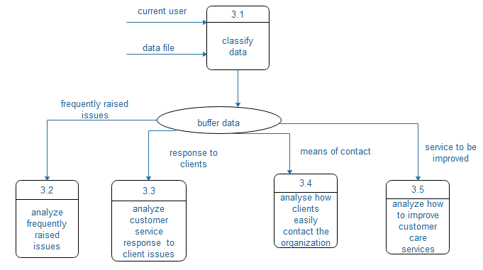

Figure 3.0.5: Level 2 Data Flow Diagram for process 3

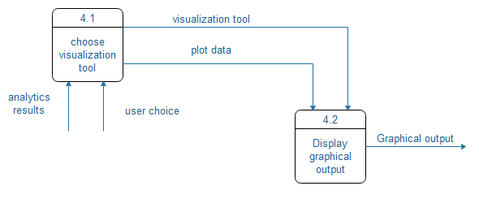

Figure 3.0.6: Level 2 Data Flow Diagram for process 2

## Design Rationale

The chosen architecture in 3.1 is good for authentication purposes, and it is cheaper to construct.

# DATA DESIGN

## Data Description

The system will not have any database. The user will be required to upload an excel sheet having a data format explained in section 4.2 This file will be uploaded for every user session and will only be stored temporarily.

## Data Dictionary

The table below shows the expected contents of each work sheet in the data store.

|  |  |  |
| --- | --- | --- |
| **COLUMNS** | **DESCRIPTION** | **DATA TYPE** |
| ID | This column specifies a unique number assigned to particular customer. | Numerical value |
| Visitor Name | These columns specify the names of a particular customer. | Text |
| Phone Contact | This column specifies the contact number of customer. | Numerical Value |
| Country | The column specifies the nationality of the particular client. | Text |
| Department | This column specifies the particular department of the customer help service | Text |
| Chat content | This column specifies a specific date and time the client contacted the organization | Numerical value |

# COMPONENT DESIGN

# Module 1: User Verification module

##### Flow Chart Diagram

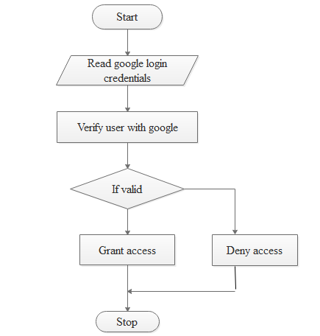

Figure 5.0.1: Flow Chart Diagram for module 1 **Module Inputs:**

* Google account login details (password and email).

**Module outputs**

* Verification result

##### Module 2: Validate data file

The uploaded file must match the file template which is described in section 4.2. When a user uploads a file, it will be checked to ensure that it matches the template. If it doesn't exactly match the template, it will be rejected and the user will be prompted upload another file. This module will be executed for every session of a user. It will only run after module 1 has granted access to the user.

##### Flow Chart Diagram

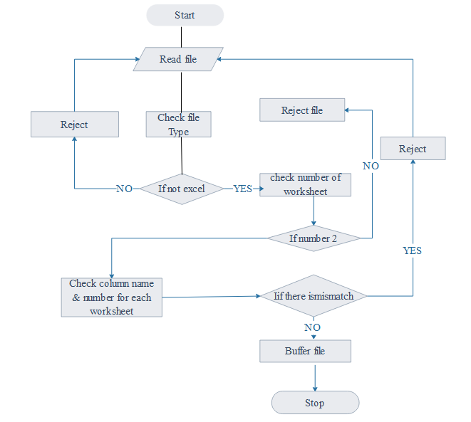

Figure 5.0.2: Flow Chart Diagram for module 2

**Module Inputs:**

* NSSF data chat excel worksheet

**Module outputs**

* File Validation Result

##### Module 3: Data Cleaning

This module involves reading the NSSF data chat excel worksheet and making valid variable names from the columns in the excel sheet. In csv file 2, we delete empty column and X.1 and use column X.

This module will be called once after execution of module 1 and 2 for every successfully loaded file.

**Module Inputs**

* NSSF data chat excel worksheet

**Module Outputs**

* Cleaned data

##### Module 4: Data Analysis

This module is the core part of the system and will be called frequently and its results will depend on the user commands. The user will choose which parameters to be analyzed and how they should be analyzed using the graphical interface.

**Module inputs:**

* User selections/choices
* NSSF data chat excel worksheet

**Module outputs:**

* Analysis results
* Textual reports

##### Module 5: Graphical Representation of results

The analytical results from module 4 will be presented in a graphical view based on the user selections. A number of graphical features including but not limited to line graphs, bar graphs, pie charts, box plots will be used by this module to display data to the user. The user will select the tool they wish to use to view the results.

**Module inputs**

* User selections/choices
* Analysis results

**Module outputs**

* Graphs

# HUMAN INTERFACE DESIGN

## Overview of User Interface

## Interface Architecture

This system will interface with the Google Verifier to validate the user credentials so as to ensure that only authorized users are accessing the system. When the user has entered his/her Google account login credentials, the details will be forwarded to the Google verifier which responds by giving validations results.

##### Interface Architecture Diagram

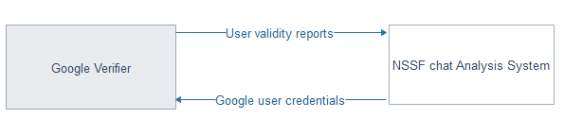

Figure 6.01: Interface Architecture Diagram

##### Interface Detailed Design

The system users will be required to have email accounts which will be added to the system by the system administrator. On attempt to access the system, the user will be authenticated by entering his/her Google credentials. The credentials will be sent to the Google verifier to check the validity of the user; the verifier then returns the results to the system which then decides whether to grant or deny access to the user.

## Screen Images

Log in Screen Image

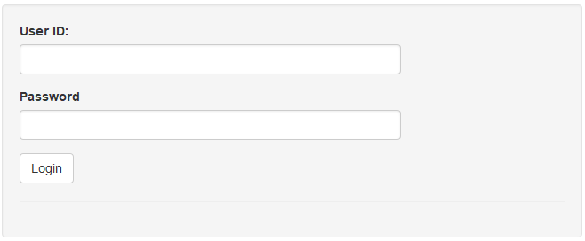

Figure 6.0.2: log in screen image

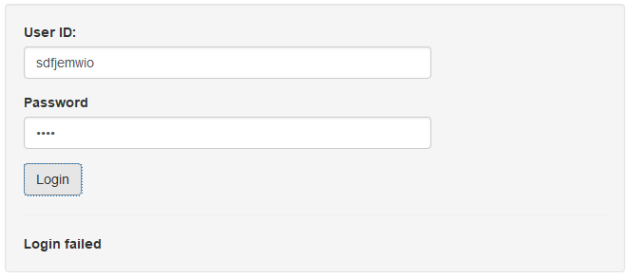

Figure 6.0.3: login failure screen image

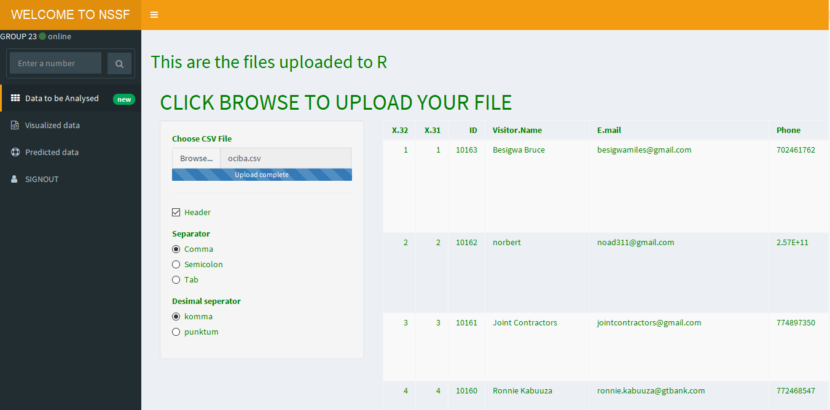

Figure 6.0.4: login success page

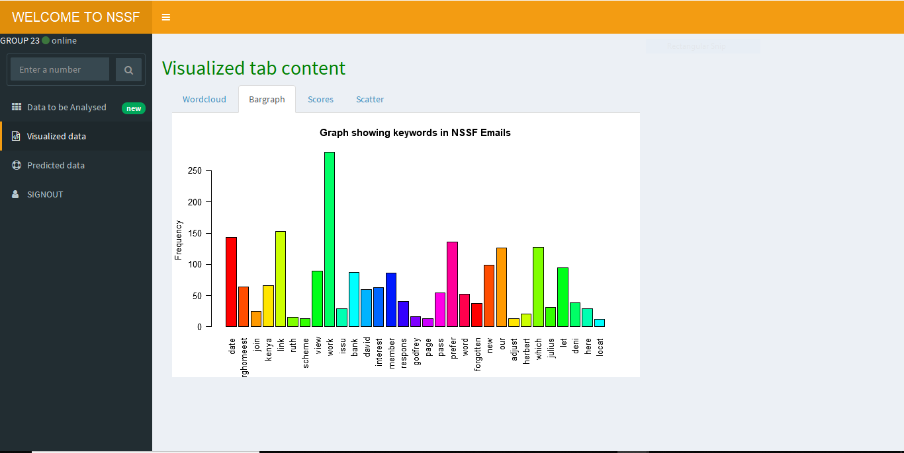

Figure 6.0.2: Screen image showing visualized data

## Screen Objects and Actions

The screen image figure 6.0.2 shows the page that all customer support workers visit first before reaching the success page. The screen image figure 6.0.3 shows the page that comes up when the login details are wrong and hence the user won’t be able to login. The screen image figure 6.0.4 shows the success page that all customer support workers visit first after logging in. The client can now be able to upload the files to be analyzed. The uploaded files are then visualized as seen in the screen image 6.0.5.

# REQUIREMENTS MATRIX

#### Requirements Table

|  |  |
| --- | --- |
| **FUNCTIONALITY REQUIREMENTS** | **REFERENCE SECTION IN SRS** |
| External Interface Requirements | 3 |
| System features | 5 |
| Other nonfunctional requirements | 6 |

Table 3: Requirements Table

# APPENDICES

## GLOSSARY

|  |  |
| --- | --- |
| **TERM** | **DEFINITION** |
| NSSF data chat excel worksheet | A file containing the datasets to be analyzed by the system. |
| Google | Google is an American multinational technology company specializing in Internet-related services and products that include on-line advertising technologies, search, cloud computing, and software. Users will be required to use their Google accounts to access the system. |
| Graphical output | This is output data that is visualized on various charts and graphs. |
| Excel file | A file which has data arranged in rows and columns. |
| Buffer | A temporary data store. |
| Data Flow Diagram | A data flow diagram (DFD) is a graphical representation of the "flow" of data through an information system, modeling its process aspects. |
| Functional Decomposition Diagram | A decomposition diagram shows a high-level function, process, organization, data subject area, or other type of object broken down into lower level, more detailed components. |
| Module | This is a part of a computer or computer program that does a particular job. |
| R Shiny package | An R package for supporting web-based data analysis systems. |
| Flow Chart | A chart showing steps to be followed when accomplishing a task. |
| User Interface | The part of the software a user interacts with. |

##### Table 4: Glossary

## References

Books [1] Gary B Sherry, Harry J Rosenblatt, System analysis and design ninth edition, Library of Congress Control Number: 2010943248, ISBN-13: 978-0-538-48161-8, ISBN-10: 0-538-481617, Course Technology, 20 Channel Center Street, Boston, MA 02210, US

Links:

<https://www.nssfug.com>